Low-Cost RF Tuning and Testing from 138MHz to 4.4GHz

Introduction

The USB 138M-4.4G SMA signal generator, simple spectrum analyser & tracking source are available for around £60 on ebay.
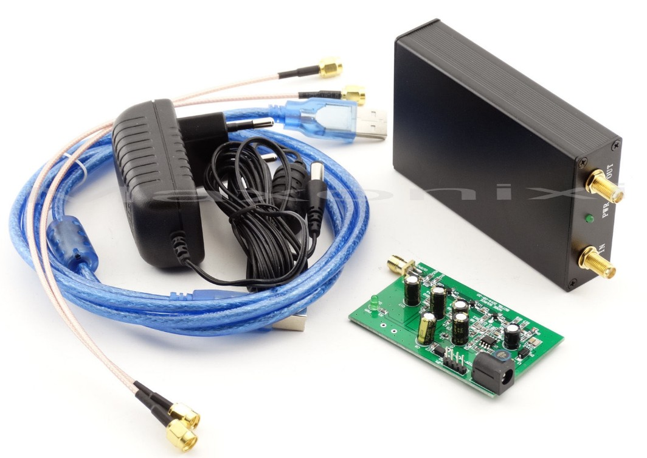

It comprises a signal generator/spectrum analyser unit tunable from 138MHz to 4.4Ghz and an identical bandwidth RF noise/tracking source. The first unit is programmable via a USB link to a PC as either a pure tone signal generator or a scanning receiver for spectrum analysis. The two functions cannot be used simultaneously but by using the spectrum analyser together with the noise source, both filter optimisation and antenna match tuning is possible.

Signal Unit Setup for Windows PCs

A user manual is included on the software CD but is not easy to follow as it is translated from Chinese.
If any programs fail to run directly from the accompanying CD, try 'Rename' and remove Chinese (square boxes) fonts and/or copy to your Desktop and run from there.

The setup process is essentially.
- Plug the unit in a PC USB port.
- Insert software CD.
- Locate the driver directory and copy the driver to the PC Desktop. \ft232,usb chip driver…
- Click and run the driver .exe file. \installl files…..
- Locate Winnwt software file and click and run.
\PC softwareWINNWT….\winnwt4.09\winnwt_4_09.exe
- If programs fail to run, try 'Rename' and remove Chinese (square boxes) fonts.
- Locate Winnwt upgrade file and run.
\PC softwareWINNWT….\winnwt4.09\winnwt_4_07_update.exe
- In 'Control Panel' select hardware devices, locate 'Ports', note COM number allocated to USB.
- Run Winnwt software shortcut, open tools/setup, change COM number as noted from above. Click OK.
- Check that 'Sweepmode' 'Single' sweep, should plot a noisy line on the Graphical display.
Filter Tuning

The filter tuning setup is shown in Figure 1
12V
PSU
Noise
Source
3dB
Pad
RF
Filter
3dB
Pad
OUT
PC +
S/W Graphical
Display

Source/
Spectrum Analyser

USB
Link

IN

Figure 1 Filter Tuning Setup

The noise/tracking source PEC gets warm and requires boxing for protection. On the main software panel, facilities are available for selecting the analyser/filter tuning range ('Sweepmode Setup') and number of samples. Setting the 'Bandwidth' section to Continuous and tuning the filter can produce the filter response required. For a 3-element interdigital filter tuning the centre element tuning screw changes the filter centre frequency. The outer tuning screws improve the band shape. The 3dB pads either side of the filter ensure that source/sink mismatches minimally affect correct tuning and filter bandshape.

Antenna Beamwidth

The signal generator (VFO) fed via the 'OUT' SMA output to an antenna in the far field can act as a transmitter to check the antenna beamwidth by suitably orienting the receive antenna when driving an amplified SDR tuned to the same frequency. The VFO accuracy is claimed around 1kHz.

Antenna Match

The antenna matching setup is shown in Figure 2
12V
PSU
Noise
Source
OUT
PC +
S/W Graphical
Display

Source/
Spectrum Analyser

USB
Link

IN
6dB
Pad
Matched
Load

10dB
Coupler
Yagi
6dB
Pad
Figure 2 Antenna Matching

Antenna matching is possible using the RF arrangement shown in Figure 2. The process is,
- Undo antenna feed cable from the 10dB coupler output and replace with a matched load.
- In Sweepmode Setup, set start and stop frequency limits to cover the antenna wanted operating band.
- Operate Single scan
- In Graph Manager, click 'Graph 1, 'Get' and tick both 'Activate ' and 'Show' boxes.
- Replace the matched load with the antenna feed cable.
- In Sweepmode Setup, operate 'Single' scan
- Adjust Yagi elements near the driven element by sliding metal tubes over them as required until the 'Single' scan response overlays the recorded matched load response. It is soon clear which elements are critical to improving the antenna match.

Figure 3 shows a photograph of the modified elements (arrowed) to match a Yagi antenna. The metal tubes were made of 0.5mm brass plate, 10mm long, bent into a tube with small long-nose pliers to make a tight fit to the 1.6mm diameter elements.

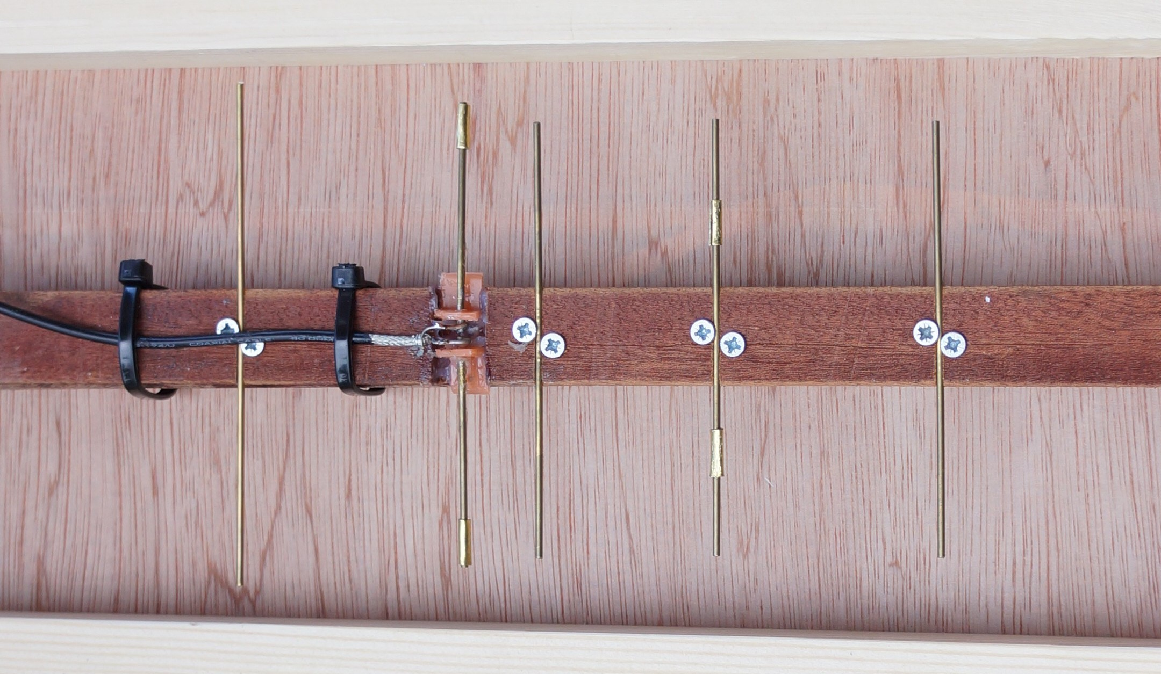
Directors
Driven
Reflector

Figure 3 Loading Element to Match 22-element H-Line Yagi

Conclusions

The signal generator and tracking source together with a few pads, 10dB coupler and matched loads can be configured to achieve results usually expected from considerably more expensive professional equipment.

PW East November 2014

