Improving Frequency Stability of the RTL2832U SDR
for dual-Channel H-line Receivers or Interferometry
Peter East

Abstract
The RTL2832U DVB-T dongle used as a cheap software defined radio (SDR) has found many applications in radio astronomy. Whilst the basic stability performance is limited, it has mostly been adequate used with available GUI software. Some novel progress has been made in frequency locking pairs of dongles, offering the possibility of tracking coherency good enough for bistatic radar and interferometry.
In this note, cheap and simple methods of improving the short and long-term frequency stability of the RTL SDR and aligning data clocks is explored.

Introduction
The RTL2832U SDR has low thermal mass so the operating temperature and the quartz crystal's frequency stability is at the mercy of the ambient temperature and the effects of internal power dissipation. Typical warm-up temperature variation is of the order 1 part in 10⁵ but this is usually masked by the frequency calibration correction of up to 1 part in 10⁴. Calibration offsets can of course be measured and corrected. Once the device has reached thermal equilibrium, however, frequency stability can improve to 1 part in 10⁶.
Juha Vierinen has posted a method of running at least three RTL units from the quartz crystal of one SDR, so locking them in frequency. The procedure involves removing crystals from slave dongles and linking to the crystal buffer amplifier inputs as described in his link…. http://kaira.sgo.fi/2013/09/16-dual-channel-coherent-digital.html
The basic frequency stability of the RTL2832U does not appear good enough for coherent applications, but this note describes a simple method of improving stability, linking a pair of SDRs and assesses their performance for application to a twin channel H-line receivers or interferometers. For this application, it is important that the data from a pair of SDRs is also accurately aligned in time and this problem is also addressed.

Basic Performance
Measurements on a standard RTL SDR show that in the USB plugged-in quiescent state, power dissipated is approximately 0.4W.
When operating, collecting data or visible with SDR# software, the dissipated/heating power increases to about 1.3W. At 1420MHz, from operating switch-on, the tuning of a standard unit drifts several kHz before reaching thermal equilibrium after maybe 10 to 15 minutes.
Longer term stability then appears to fluctuate by a few hundred Hertz.
Operated with SDR# software, this performance when thermally stable, is adequate for most applications and any calibration error can be corrected by suitable offsets.
However, when the SDR is used intermittently and data collected with rtl_sdr software tools, the few kHz tuning drift over the observation period can colour Hydrogen line spectrum analysis detail for example.
Not all RTL2832U dongles are equal. More than half the dongles bought from various internet sources exhibit a 30dB gain reduction at frequencies above about 1380MHz after several minutes of continuous operation. This appears to be a thermal effect and seems to be cured by keeping them cooled.
Tests running two dongles on one or two PC/laptops using the rtl_sdr software tool tasking two dongles simultaneously has shown a very wide variation between actual dongle start-up times of up to several tens of milliseconds; almost certainly due to operating system preferential housekeeping tasks.

Improving Frequency Stability
The method adopted here takes advantage of the low SDR thermal mass, by blowing copious ambient air across bare SDR pec's to extract dissipated heat above ambient, so minimising the SDR quartz crystal temperature rise. To improve the cooling efficiency mini heatsinks were thermo-plastered onto the integrated circuits and crystal. With these modifications, thermal equilibrium is achieved more quickly, now in a few tens of seconds. Figure 1 shows some switch-on temperature drift comparisons.

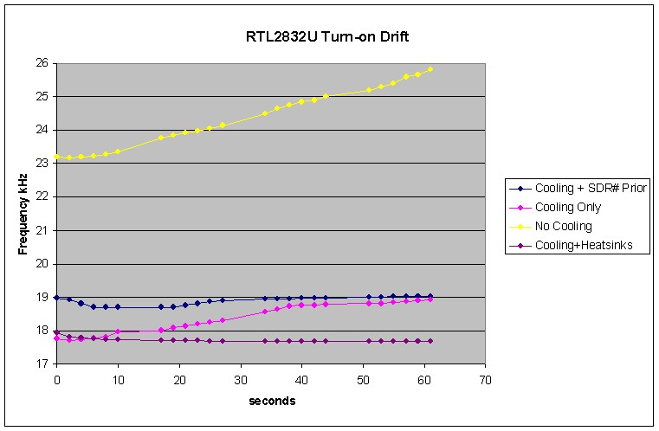

Figure 1 RTL SDR Turn-on Tuning Drift

Referring to Figure 1, the green curve shows the basic switch-on drift of a standard, unmodified unit with time as the dissipated power warms it up. The drift rate is approximately 3kHz in 60 seconds. It is clear from this curve that thermal equilibrium is not yet reached. It is obvious that were data collected in this period the source signal spectrum would be spread accordingly.
The magenta curve shows the frequency drift with fan cooling. Already it is observed that the initial frequency offset, due to the quiescent 0.4W dissipation (~5kHz) has been compensated. Also under full working power, thermal equilibrium is approached after about 40 seconds. The overall drift in 60 seconds is reduced to about a third of the uncooled case.
The blue curve results from preheating the SDR using SDR# to run the dongle prior to switching to rtl_sdr software to collect the data. In this case the drift deviation is less than 0.2kHz and thermal equilibrium is reached within 30 seconds. Once thermal equilibrium is reached, indicated frequency variation of less than 10Hz is observed. Separating this data in time produces data with an indicated stability of less than 1 part in 10⁸. The purple curve shows the excellent result when small aluminium heatsinks are mounted on all ICs. 10Hz stability is achieved within a few seconds of switch-on.
Calibration offsets still need correction however, and will need adjusting for the current ambient temperature.

Mechanical Construction
Figure 2 shows the mechanical layout. The two bare dongles are aligned side-by-side and mounted in a folded aluminium box with two 5V, 0.6W fans, one blowing in and the rear fan sucking out. These are driven by a 5V power supply unit. The dongles, of course, being powered from the laptop USB ports. The mini aluminium heat sinks on all IC's are evident.

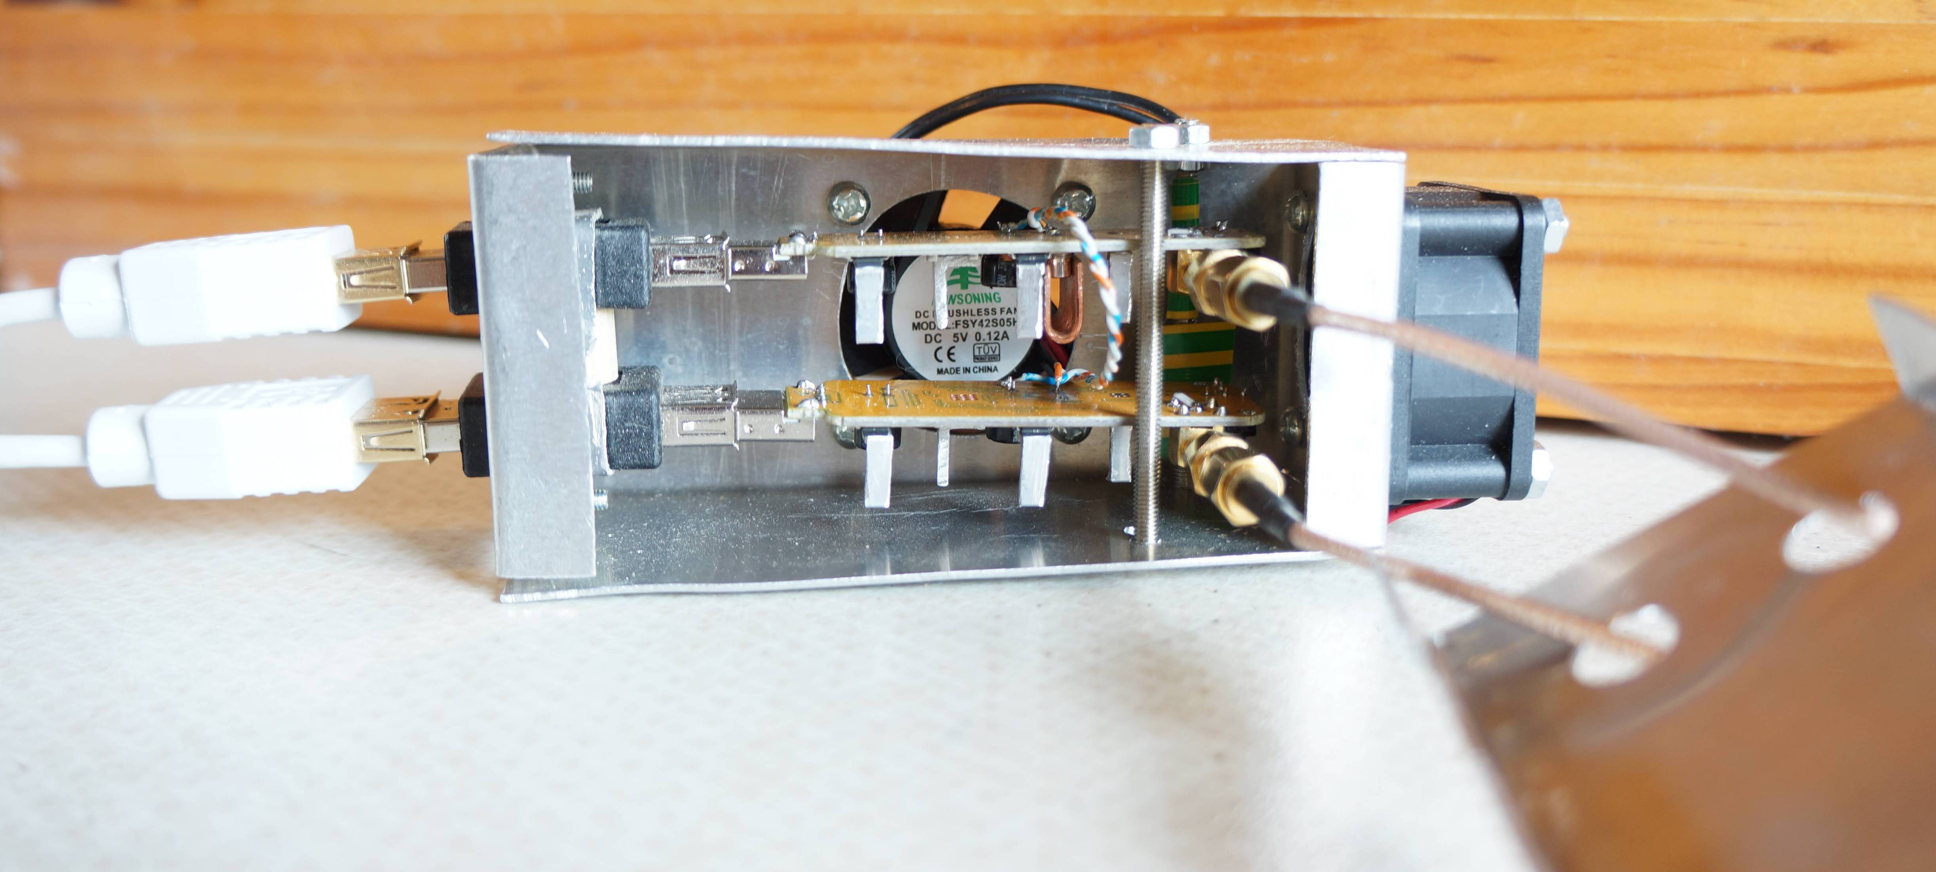

Figure 2 Duo-SDR Cooling Construction

The aluminium lid, to the right clips on the box allowing the RF connectors to feed through.
150Ω chip resistors were soldered across the RTL RF inputs to reduce the dongle nominal 75Ω input impedance to match the 50Ω RF amplifier/filter characteristic impedance.
Twisted pair rather than coax is used for interconnecting the crystal inputs to keep the connection convenient and short.

Operational Tests
Figure 3 shows the test set-up. A stable 1420MHz pure-tone signal is fed to two RTL SDRs via an RF power splitter. The two SDR USB outputs are fed to two laptops which are data-synchronised by the data capture software running the rtl_sdr tool. True synchronism depends on the laptop clocks running in synchronism. This is optimised in linux using the 'chrony' system tool and in Windows by synchronising both laptops to the same internet time server. Experience has shown that different laptop clocks do not stay in synchronism for long, so time synchronising should always be carried out prior to serious measurement.
Data collected is sectioned and sections analysed for indicated frequency, phase tracking and relative delay.

Boxed
RTL
Dongles
USB
ports
1420MHz
source
Laptops
RF
Power
splitter

Figure 3 Test Schematic

Although it has shown to be feasible to lock two dongles in frequency, it is unlikely that the data clocks will be aligned. For perfect frequency alignment, clock misalignment will be exhibited as a constant phase shift.
Correlation of data sets has shown that laptop data delays, even with time synchronised laptops can be a few tens of milliseconds. These delay differences can go either way and are probably due to operating system housekeeping. Both Windows and Linux exhibit time variations.
Correlation delays are determined using a wideband noise source replacing the oscillator shown in Figure 2 and special purpose software (see Appendix). The injected noise power is switched on for a short period and should be sufficient to dominate over system noise.
Tracking accuracy better than half the clock period is observed.

Figure 4 shows an implementation for obtaining both calibration and observation data.

Boxed
RTL
Dongles

USB
ports
RF
Power
splitter
RF
Power
splitter
RF
Power
splitter
Antennas
+
Preamplifiers
Switched Noise
source

Figure 4 Time Tracking Primer

Simultaneous data are recorded, first with the noise source switched on at a level which swamps the antenna signal for a second or so before the wanted signal data.
Data files are then processed in software suitable for separating calibration and source data, determining the timing alignment, and then aligning source data records prior to examining the source signals for interferometer phase variation, for example.

Time Correlation Alignment
As well as the operation system timing uncertainty, due to the separate dongle clocks, the antenna waveforms are not sampled at precisely the same time, so after system delay compensation, there will be a systematic phase error in the two data records. It is possible to estimate this phase error from the correlation results, but as it is initially unknown, the traditional complex correlation formulae cannot be applied.
However, the signal amplitudes in the two channels do still correlate in time and by allowing for the mean amplitude offsets, the following simple amplitude correlation procedure can be adopted.
If, datA and datB are the two data series derived using the Osmocom rtl_sdr, .bin files, the sample amplitudes are derived from (sequential real and imaginary components); for n = 0,1…..etc:

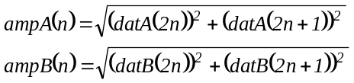

The correlation process applies the following formula, which produces a single peak only when the two records align as shown in Figure 5

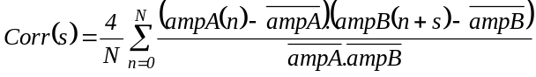

where, 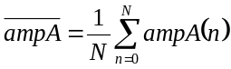 and 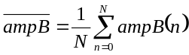 are the group sample amplitude averages.

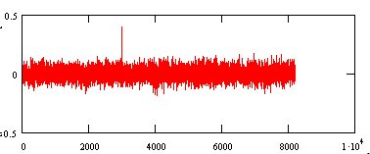

Figure 5 Correlation Result

Figure 5 was based on a sample group N, of 512 and demonstrated alignment at sample number 2979, peak = 0.37 and sample number 2980, peak = 0.4. The sample rate was 250kHz resulting in data B arriving some 11.92ms before data A. Improved signal-to-noise ratio is possible with increasing group sizes but the software correlation time increases accordingly.

Software
Two software tools have been written. The first carrying out correlation, (COR_TIM.exe) to find the time slip and the second (F_ALIGN.exe) to trim the data files so that they align to the optimum data sample and are then useful for phase measurement.

Phase Measurement
Once the data streams have been aligned phase comparison can be effected either globally for narrow band signals or selectively in active frequency (filtered or FFT) channels using the I/Q data by applying the trigonometrical identities,

or in data terms,
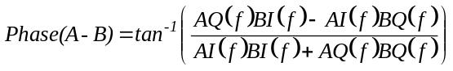
where, AI and BQ etc. represent the FFT bin I and Q components.
The conventional interferometer sum and difference outputs can also be synthesized.
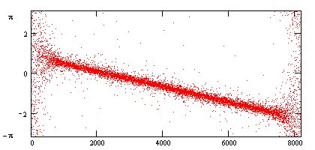
Figure 6 Residual Phase v Frequency

Figure 6 is the result of applying the phase equation to the bins of an FFT covering the whole of the SDR band (250kHz). Note that the phase changes linearly with frequency as expected from the residual delay of the two SDR data clocks not aligning. The residual delay is calculated from dt = dϕ/df or π/(2π.250kHz) = 2μs. This is confirmed by the two adjacent correlation peaks being roughly equal. The plot shows that this clock timing phase error can be calibrated by an initial noise injection for each measurement so that interferometer phase data can be correctly identified.

Discussion
The techniques described above have been proven on noise calibration data but there are attractive implications for wider economical application in the general radio astronomy field. For the signal processing, very powerful PC's are available but work on a suitable software Graphic User Interface to run the software tools would be of benefit. For data collection, credit card PC's like the Raspberry Pi controlled over a network with software such as PUTTY would maintain the economical mantra.
A receiver channel could comprise, an antenna, broadband rf amplification plus a suitable filter, an SDR dongle and a Raspberry PI.
For the hydrogen line work, the cost with cabling and couplers, is about £250-£300.
Two application possibilities are,

a) Interferometry
The complex FFT outputs containing the wanted signal can be sum-difference combined for conventional analysis. With low level noise signals, integration may be necessary to improve the signal-to noise ratio. This can be carried out by averaging the amplitude processed outputs of successive short FFT data blocks to produce the √n improvement required. Drift scan interferometry can produce very large files.

b) Phased Arrays
The techniques described here can be applied to multiple antennas. A central temperature-compensated crystal oscillator at 28.8MHz can be amplified and split to feed multiple SDR dongles to lock them all in frequency. Similarly a suitably amplified noise source can be divided for the initial calibration sequence. To produce a single broadside beam, the complex FFT outputs are combined directly prior to determining the amplitude for sensitivity-improvement summation. It is feasible to correct and adjust relative phase for beam steering in the post processing.

Conclusions
The paper has shown that with some simple modifications, the frequency stability of very cheap DVB-T dongles can be improved, at modest cost, to a few Hz at 1400MHz matching professional equipment performance. Coupling the crystal circuits between a pair of dongles and mounted as described, serious vector interferometry is possible. The main problem is the amount of post data collection processing for data alignment and phase extraction required, but with software written in 'C' language the delay between data collection and results viewing can be minimised.
Very accurate and stable measurement of the Hydrogen line should add significantly to the quality of data and derived results.

Appendix - Software Processes
Programs with postscript '2' have been modified to cope with very large data files, up to and exceeding 2GHz

1. Data Collection - RN_RTLAT2.exe (run_rtl_at2 - linux)
This uses the PC clock to run the rtl_sdr2* program at the command-line set time, generates a bin file which is then processed with the FFT algorithm to output spectrum averaged text file.
Separate PC clocks should be updated at the same time to the same internet server. PC clocks drift in time accuracy and should be re-set prior to serious measurement.

To achieve near simultaneous recording, two terminal windows, one for each SDR, run a copy of the control software that is set with the desired recording parameters.
The command format is:-
>rn_rtlat2 <”rtl_sdr2 data.bin + command line”>< Number of FFT points><hr min sec><hour offset>

Typical control software commands to run two SDRs (-d 0 and –d 1) on a single computer for MS WINDOWS are,

>rn_rtlat2 “./rtl_sdr2 dat0.bin –f 1420e6 –d 0 –g 49 –n 100e6” 256 14 24 00 1

> rn_rtlat2 “./rtl_sdr2 dat1.bin –f 1420e6 –d 1 –g 49 –n 100e6” 256 14 24 00 1

These are run in two Command windows set to the working directory, which also contains the Osmocom rtl_sdr tools.

2. Correlating Data Sets cor_tim2.exe (cor_tim2 - linux)
Although multiple SDR dongles can be programmed to sample data at the same time, PC housekeeping and internal clock monitoring is unsynchronised so that data collection start times can vary by several tens of milliseconds. This correlating software identifies the time slip for correction. With this information, data sets can be aligned to within a data clock period.

The command format is:-
cor_tim2 <infile1> <infile2> <outfile> <sample length> <No 8192 blocks>

The number of data blocks chosen for this command only needs to be large enough to ensure the correlation peak becomes evident.
A typical command line and response is shown in Figure A1.

~/Desktop/Data > ./cor_tim2 aa01.bin aa02.bin ffo.txt 512 8

No. Input Bytes = 4000000 No. of IQ Samples=65536

Block Sample Corr Offset Corr Offset
Size Width Peak1 1 on 2 Peak2 2 on 1

8192 512 0.210 -255 0.183 -4675
No IQ amplitudes cross-correlated: = 7679
8192 512 0.225 3216 0.682 8013
No IQ amplitudes cross-correlated: = 15871
8192 512 0.225 3216 0.682 8013
No IQ amplitudes cross-correlated: = 24063
8192 512 0.225 3216 0.682 8013
No IQ amplitudes cross-correlated: = 32255
8192 512 0.225 3216 0.682 8013
No IQ amplitudes cross-correlated: = 40447
8192 512 0.225 3216 0.682 8013
No IQ amplitudes cross-correlated: = 48639
8192 512 0.225 3216 0.682 8013
No IQ amplitudes cross-correlated: = 56831
8192 512 0.225 3216 0.682 8013
No IQ amplitudes cross-correlated: = 65023
Infile1=aa01.bin Infile2=aa02.bin Outfile=ffo.txt No Samples=512
Figure A1 Correlation Tool Response for Data Files

Perfect correlation with data clock alignment is unity. This example shows a correlation of peak of 0.682, comparing a sample block of 512 of file 2 located on file 1, 8013 samples later. Random noise peaks around the 0.2 are visible, but the true correlation peak or adjacent peaks are normally more than double this level. A requirement is for the calibration noise source to dominate over system noise. To avoid possible distortion at the file start, the software ignores the first 7000 IQ pairs.

3. Data Set Alignment f_align2.exe (f_align2 - linux)
The command format is:-
f_align2 <file_In> <file_Out> <No of 8192 IQ blocks> <Align Address>

For the files in Figure A1, we need to determine the alignment address and file size (number of 8192 IQ blocks).
For a 4000000byte file, in this example, the number of useable 8192 IQ data blocks is given by, Int(4000000-2(7000+8013))/2/8192 ~ 242 complete 8192 IQ blocks.
The alignment start address for files 1 and 2 are (7000+8013) and 7000 respectively. The 7000 offset is included within both cor_tim2 and f_align2.

The example relevant commands are,
f_align2 aa01.bin aa01a.bin 242 8013
f_align2 aa02.bin aa02a.bin 242 0
This will produce two files of the same length and virtually data clock synchronised. This is demonstrated re-running COR_TIM with the new data files as shown in Figure A2.

~/Desktop/Data > ./cor_tim2 aa01.bin aa02.bin ffo.txt 512 8

No. Input Bytes = 4000000 No. of IQ Samples=65536

Block Sample Corr Offset Corr Offset
Size Width Peak1 1 on 2 Peak2 2 on 1

8192 512 0.210 -255 0.183 -4675
No IQ amplitudes cross-correlated: = 7679
8192 512 0.225 3216 0.682 8013
No IQ amplitudes cross-correlated: = 15871
8192 512 0.225 3216 0.682 8013
No IQ amplitudes cross-correlated: = 24063
8192 512 0.225 3216 0.682 8013
No IQ amplitudes cross-correlated: = 32255
8192 512 0.225 3216 0.682 8013
No IQ amplitudes cross-correlated: = 40447
8192 512 0.225 3216 0.682 8013
No IQ amplitudes cross-correlated: = 48639
8192 512 0.225 3216 0.682 8013
No IQ amplitudes cross-correlated: = 56831
8192 512 0.225 3216 0.682 8013
No IQ amplitudes cross-correlated: = 65023
Infile1=aa01.bin Infile2=aa02.bin Outfile=ffo.txt No Samples=512
Figure A2 Correlation Tool Response for Aligned Files

4. Data Analysis bin_txtr2.exe (bin_txtr2 - linux)
This tool converts binary data to text format so that data samples can be processed using Excel or Math CAD software.
The format is,
bin_txtr2 <binfile_In> <Textfile_Out> <No. of 8192 IQ blocks> <Start block> <End Block>
Text files can be very large but a typical example is,
bin_txtr2 aa01a.bin aa01aa.txt 0 512
This produces text files formatted with sample number, Q data, I data; 512*8192 IQ pairs; about 94MB in size.

5. Software Link
http://www.y1pwe.co.uk/RAProgs/NewSW2.zip

Peter W East. Issue 2. May 2015

* RTL tool rtl_sdr2 has been modified for Linux by GM Gancio to enable recording of very large (>2GB) data files

