Some Folding Algorithm Variants for Optimizing Pulsar SNR for Small Apertures
Peter W East

Abstract
Pulsar hunting is not always successful due to system noise, RFI, scintillation, drift scan under-illumination or just plain acquisition limitations of small antenna apertures. Some folding algorithm tweaks are described in this article to ensure that the best possible pulse fidelity is extracted from a pulsar present in a data record.

Introduction
The basic folding algorithm involves dividing the detected data record into intervals exactly equal to the expected pulsar period and parallel-adding these coherently. This ensures that any pulsar pulse present occurs at the same point in each interval so adds linearly. The detected system noise, assumed random, sums as the amplitude square-root, ensuring the pulse data signal-to-noise ratio (SNR) increases, providing each interval's pulse exceeds a certain positive level. If the interval or section SNR falls below this level, then the potential final SNR is reduced. This critical level is given by SNR_{final}/√N, where N is the number of intervals/sections summed.
Six folding algorithm variants are described to process some real observation data without any RFI modification, but still allows the best possible final data SNR to be obtained. The algorithms’ functions and operation are demonstrated using data from an extended drift scan observation.
Note, the algorithm equations 1 to 6 in the following 'Folding Algorithms' section are in a pseudo-descriptive form for information but have been implemented in 'C' for this analysis.

Example Observation Data File
16800 seconds of drift scan data was collected with a small twin-Yagi antenna with elevation and azimuth beam widths of 14 and 28 degrees. The target was B0329+54 and the antenna 3dB half-width beam dwell was around 3 hours. The extended trial dwell allowed for periods at the beginning and end where low target signal levels were expected to better visualize and accentuate pulsar detection over the azimuth beam maximum response. The data record contained some minor RFI and the only RFI reduction feature included was for any spikes greater than 3.5 times each band rms to be reduced by a third.

Folding Algorithms
1. Basic Fold - finds pulsar but poor resolution

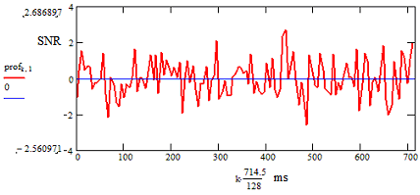
Figure 1 Basic folding, 128 bins, resolution ~5.6 ms. Target Pulsar SNR = 2.7:1 (at bin No: 79 ~ 441ms/714.5ms)

The basic folding algorithm limits the number of fold bins, and final time resolution, to numerically equal the pulsar period divided by the average pulse half-height width (for B0329, 714.5/6.5 ~ 110). In this way, the folding averaging process reduces the data bandwidth to effectively just pass the pulsar pulse duration so maximizing the potential SNR.

Unfortunately, unless the pulse peak happens to lie in the center of a fold resolution bin, this is not so, as shown in Figure 1 with 128 bins, where the indicated target SNR = 2.7:1.
With this estimation alone, the probability of confirming pulsar detection is very low.

If, p_{b.n} is the n^{th} period in the data record, each period sampled into B bins, where b = 0 -> B-1, the basic folding (summing) of N coherent periods can be described by,

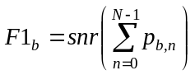 (1)
where, F1_{b} defines the folded equivalent data SNR at bin 'b'; for basic folding the optimum number of fold bins B = P/W.
The function snr( ), calculates the folded data SNR. The summation term coherently sums the N discrete pulsar periods p_{b.n} , where n -> 0 to N-1.

If the folding bin resolution is simply increased to around 0.7 ms (1024 bins), higher frequency noise is allowed in and the target pulsar pulse is further obscured as typically shown in Figure 2.

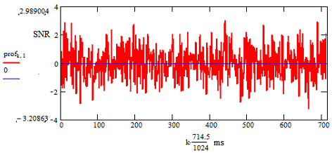
Figure 2 Basic folding, 1024 bins, bin resolution ~ 0.7 ms

2. Matched-filter Fold - optimizes SNR and resolution
An obvious alternative to basic folding is to low-pass filter the data to achieve the pulse-matched data bandwidth. In this case there is no restriction on bin numbers and much better resolution is possible to more accurately identify the pulse peak. Figures 2 and 3 show increased target detectability between without and with band limiting. The indicated SNR increases to 4.1:1 and is slightly more credible as a B0329 pulsar acquisition.

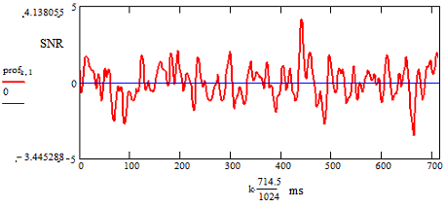
Figure 3 Matched-filter folding, bin resolution ~ 0.7 ms. Target Pulsar SNR = 4.1:1 at bin 631 ~ 441ms/714.5ms

Also the improved resolution allows checking the pulsar target pulse width adding some detection confidence.

This matched-filter process SNR at bin 'b' is now described by,

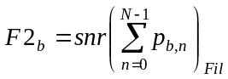 (2)
where now, the number of resolution bins B, can be much greater than P/W.
The suffix addition Fil indicates the data is pre-filtered to just pass the pulsar pulse bandwidth. The filtering can be implemented by low-pass data filtering or FFT convolution with a pulse width matching Gaussian pulse.

3. Partial Folding - simplifies further analysis
In partial folding, the data is folded into a number of period-synchronized blocks or sections and each are matched-filter folded. This process partially averages and compresses the data, making it easier and quicker to analyze further. No information is lost.
In Figure 4, the 16800 seconds of drift scan data from the 28 degree beamwidth antenna is coherently divided and folded into 128 sections or equivalent periods. The measured target SNR in each section is plotted against section number.
These sections data can be processed in several ways but summing folds from all sections and calculating the final SNR produces exactly the same result as Figure 3 indicating that no information is lost.

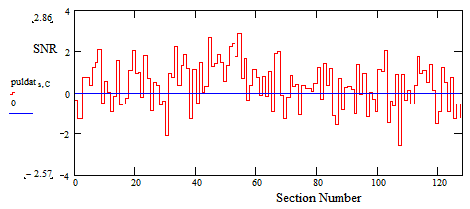
Figure 4 Matched-filter partial folding into 128 sections - target pulse bin SNR

The partial folding algorithm is described by,

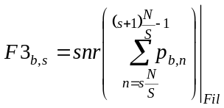 (3)

F3_{b,s} specifies the match-filtered fold SNR at bin number 'b' of the folded section 's', where S is the total number of sections and s = 0 -> S - 1.
Each section synchronously folds N/S consecutive pulsar periods.

As expected for this weak signal, the section target signal SNRs are low and comparable to the folded noise level. If the example data were just random noise, the mean should be zero with the SNR peaks around ±3:1 SNR. It is noted that in Figure 4, that there is a region between sections 40 and 60 that is largely positive, (signifying the possibility of a strong target signal) but towards the end of the observation the data appears closer to zero mean (target exiting the antenna beam?).
The estimated antenna 3dB dwell on target for this example is between sections 10 an 90.

4. Cumulative Folding - finds best SNR in full data
With cumulative folding, first the target folded SNR of section 0 is plotted relative to the x-axis section 0. Then sections 0 and 1 folds are summed and the combined SNR plotted relative to x-axis section 1. And so on until all sections are summed and plotted relative to section 127. In this way the growth of the target SNR is visualized, indicating strong (steep rise) and weak (falling SNR) scintillating or target acquisition sections.
The cumulative folding algorithm operates on the partially folded and filtered section data, F3_{b,s} and is described by,

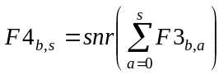 (4)

F4_{b,s} specifies the cumulative fold SNR at bin number 'b' of the sum of all sections numbers less than and including section 's'.

The example data cumulative result at the target bin peak position is plotted in Figure 5.

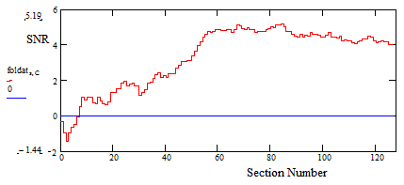
Figure 5 Matched-filter section cumulative target folding - Best Target Pulsar SNR = 5.2:1

The obvious conclusion from cumulative SNR plot is that there is a significant SNR increase between sections 30 and 60, but the trend is to a reduction in SNR towards higher section numbers. A maximum cumulative SNR of 5.2:1 is indicated around section 85, reducing to 4.1:1 when all the sections are accumulated, the final figure agreeing with all the data folded at section 127 as in Figure 3.
An immediate suggestion might be to trim the data file at a point equivalent to section 85, but maybe we can do better!

Figure 6 plots the target bin peak together with all noise-containing bins outside the target pulse showing that the noise typically lies within ±3 x rms level (SNR ≡ 3:1) and indicates no significant or long-term growth with the accumulating sections.

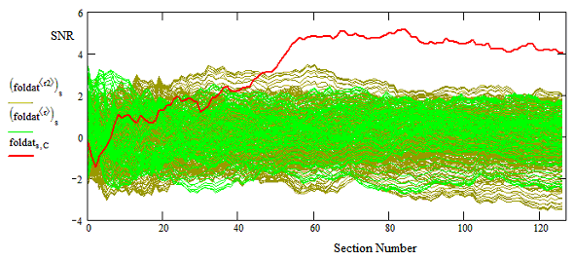
Figure 6 Matched-filter section cumulative folding - target + noise bins outside target

The obvious rise and fall of the accumulated target SNR suggests that there is a continuous portion of the data that maximizes the target SNR and the following algorithm variants identify and locate this optimum range.

5. Rolling Block Average Folding - finds optimum SNR extent
For this rolling average block fold algorithm, first the maximum SNR (target or noise) of all single section folds is plotted relative to x-axis section 0 in Figure 7. Then the maximum SNR of all adjacent section sums is plotted relative to x-axis section 1. Similarly the maximum SNR of all 3 adjacent section sums is plotted relative to section 2 and so on to all 128 sections folded together and summed with the SNR plotted relative to section 127; this final SNR figure again agreeing with the original all data fold result.
This algorithm effectively does a variable section block scan across all sections and reports the maximum SNR observed within each scan-block range. Assuming a constant amplitude pulsar pulse is present then a rising square-root curve would be expected. For a scintillating pulse, the plotted curve maximum indicates the optimum extent of the densest target region in the observation.

The rolling average block folding algorithm is described by,

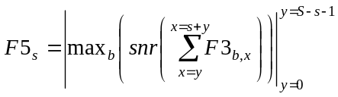 (5)
where, the max_{b}( ) function records the maximum of each variable summation/fold bin 'b' data SNR maximum.

Figure 7 plot maximum shows the minimum number of adjacent summed sections needed to ensure maximum target signal amplitude or scintillation optimum SNR. In this case, just 36 sections folded together (approximately 80 minutes) out of the total 16800 seconds observation would generate an increased target SNR of 6.8:1. In fact, just 14 sections generates an SNR of 6.5:1 (approximately 31 minute observation time).
Note that in some early blocks containing only a few sections, these could report a noise or RFI spike peak - this can be checked by reporting the corresponding peak bin number in parallel since once the accumulating target dominates the bin report number will stabilize at the target final value.
Whilst this algorithm indicates the optimum wanted data block extent, it does not identify the optimum position in the data, which is left to algorithm 6 below.

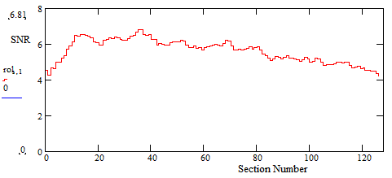
Figure 7 Rolling Block Average Peak Plot - Target Pulsar Best Maximum SNR = 6.8:1

6. Optimum Block Fold - finds best SNR data range center
This final fold algorithm locates the section center that produces the indicated optimum section block from Algorithm 5, above. With the optimum extent, in this example, 36 sections, the sections (0 to 35) are summed and the peak SNR plotted relative to the halfway x-axis section 18 in Figure 8. Then the next 36 sections 2 to 37 are summed and the SNR result is plotted relative to section 19 etc:. Until the final data plot at section 109, summing sections 91 to 127. The result is shown in Figure 8 from which several conclusions can be drawn, not the least being the obvious received signal strength tracking the static antenna beam pattern.

The optimum block center search algorithm is written,

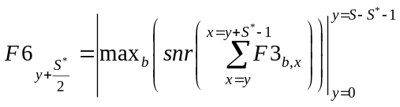 (6)

where, S* is the optimum range identified by the peak position plot of Algorithm F5.
Plotting F6_{y+S*/2} over the variable 'y' range 0 -> (S - S*- 1) generates a plot as in Figure 8.
The maximum occurring at SNR 6.8:1, identifying the optimum center section for the 36-section fold as section 50.

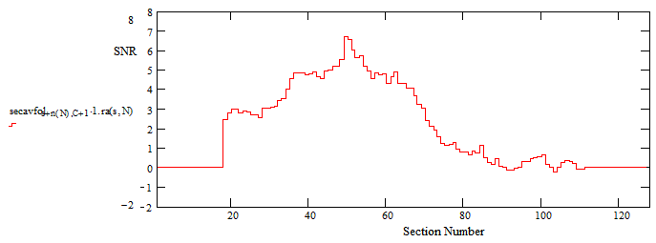
Figure 8 Optimum 36-Section Fold (S* = 36 ), Target Pulse bin SNR Peaking at Section 50

The extended observation (above section 90) as the target drifts out of the antenna beam confirms the expectation of zero mean system noise.

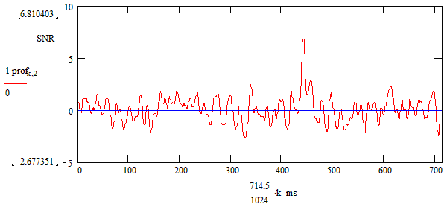
Figure 9 Optimum 36-Section Fold, Centered on Section 50, SNR = 6.8:1.

Figure 9 shows the target bin SNR result with the optimum 36-section range, centered on section 50 when the peak target SNR indicates an SNR of 6.8:1.

7. De-dispersion Folding
De-dispersion compensates for the frequency dispersion of pulsar signals due to interference with free electrons in space with the effect of delaying the arrival of low frequency components relative to higher frequency components. The relative delay for narrow RF bands can be treated as linear and given by,

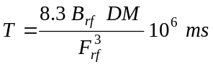 (7)
where, B_{rf} is the receiver RF bandwidth, F_{rf} is the RF band center frequency and DM is the pulsar characteristic dispersion measure.

If, ^{f}p_{b,n} represents the n^{th} period in sub-band number f of F sub-bands, then de-dispersed periods about the pulsar pulse center sub-band can be represented by,

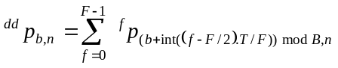 (8)

where, T/F is the delay per sub-band.
The int function defines the integer part of the bracketed terms and the mod function defines the remainder part of the bracketed terms from division by the number of fold bins B.
De-dispersion correction about the pulse center ensures that the de-dispersed pulse remains located in the original non-dispersed bin position.
The equivalent de-dispersed match-filtered fold SNR at bin number 'b' of the folded section 's', where S is the total number of sections and s = 0 -> S - 1.

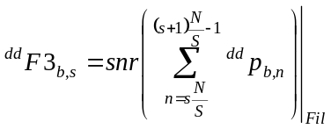 (9)

Each section synchronously folds N/S consecutive de-dispersed pulsar periods.
Although presented last to highlight the pulsar dispersed property, de-dispersion is preferred initially and the searching fold algorithms 4,5 and 6, use the results of Equation 9 instead of Equation 3.
Finally, Figure 10 plots the optimum 36-section sum SNR after de-dispersion, indicating a further improvement of SNR from 6.8:1 to 7.4:1.

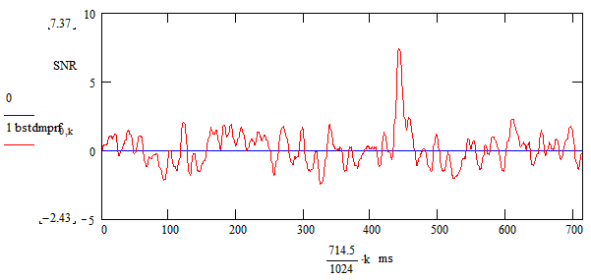
Figure 10 Optimum 36 -Section Fold, De-dispersed Result. SNR = 7.4:1

Conclusions
With drift-scan pulsar observations, due to target scintillation and/or antenna beam pointing accuracy, it is not always advisable to rely on restricting the observation time to be controlled by the antenna 3dB beam-width. On the other hand by extending the observation time, it allows target confirmation by noting the target is rejected out of beam whereas any repetitive pulse-type RFI masquerades might be relatively unaffected.
This article has shown that by adapting the standard folding algorithm the optimum region for maximizing the final measured target SNR can be found. An important message here is that no data was rejected, although with the tools described, weak and low contribution data sections and/or sub-bands within this range are easily identified and could have been rejected.
From the original basic fold SNR estimate of 2.7:1, by choosing the optimum reception region the final estimate of 7.4:1 is much more convincing.
The key aspect of the fold algorithm adaptations described is that they allow detailed investigation and tracking of scintillation and amplitude/time variations in collected data and provide improved evidence of genuine intercepts.
By extracting and fully analyzing the optimum SNR data range, it has been found that other pulsar parameter search indicators, such as period/p-dot correlation and dispersion, become more convincing.

Caution - So what can be learned from this exercise?
Automatic software analysis of B0329+54 strongly scintillating data is unlikely to offer the best SNR result. Data manipulation/selection/rejection schemes intended for RFI suppression should be well understood to ensure confidence in the final SNR result.
Two confidence criteria were applied in this exercise, the first to note the amplitude tracking the antenna beam pattern and the second to closely track the de-dispersion theoretical response. Both were positive. However, it is recognized that at relatively low final SNRs, the influence of system noise is still evident. For example, if sn is the actual SNR, there is a significant probability that the measured value is in the range sn ± 1. This means that at low SNRs this noise uncertainty can still affect the accuracy of period, pdot and dispersion measure (DM) searches. Period search accuracy is dependent upon valid pulsar intercept duration and for dispersion search, be aware that the residual base noise adds a zero DM component which can affect DM estimation accuracy.
PWEast, March 2024

