On the Identification and Validation of Low SNR Pulsar Signals

Introduction
In small aperture pulsar detection systems, even very long-time data records may only produce detected SNR's of maybe only 2 to 5. Since this is the expected range of Gaussian noise peaks there will always be some ambiguity in identifying a true pulsar pulse, so an extreme validation routine is necessary.

Finding and Validating Low-level Pulsar Signals

After data collection, the procedure is to downsample the RTLSDR I/Q data by averaging the IQ amplitudes to 1ms output data clock to produce 3-files, one for each receiver band. The downsampled data is then adjusted for equal amplitudes to generate a summed output file.

The result of a good example's 3-band summed and downsampled data file after folding in 375, 2ms bins is shown below.
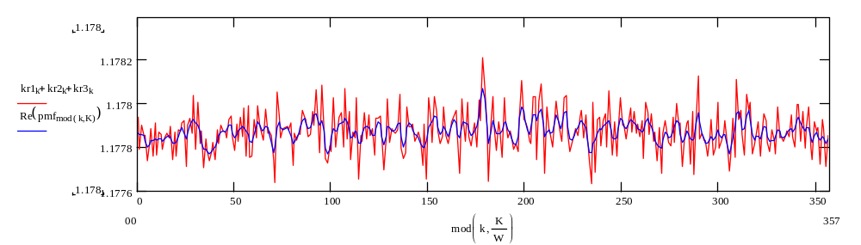

The red curve shows the standard folded result and has an SNR of 3.6, whereas the blue data shows the enhanced folding algorithm improving the SNR in this instance to 4.4. In both cases the prime candidate is clearly evident, and the next candidate at bin 289 exhibits an SNR of 2.7 for standard folding and 2.0 in the enhanced folding - a modest discrimination.

After a preliminary check on data quality - acceptable RFI on downsampled data, data aligned, bands de-dispersed, and initial drift, RF spikes etc: removed or nulled.
The recommended validation routine after candidate identification and period search to confirm identity comprises the tests.
1. Candidate pulsar frequency within an acceptable range of receiver clock accuracy
2. Correlation between data file sections
3. Correlation of multi-period folds
4. Correlation between receiver bands
5. Pulse width and shape confirmed
6. Confirmation of typical scintillation
7. Correct time shift, amplitude and width spread confirmed with ppm period change
8. Correct time shift, amplitude and width spread confirmed with de-dispersion variations
A true pulsar will pass all validation tests and show day-to-day consistency.

Folding Algorithm Properties
The primary function of the folding algorithm matches the set tuning period exactly to the pulsar period so that the pulsar phase is fixed in position. Consequently, the pulsar amplitudes integrate to make the pulsar visible. Noise and interference that does not match the tuning period is summed incoherently to improve the pulsar signal-to-noise ratio. Fully incoherent noise amplitudes will reduce by the square root of the number of periods in the data file duration. In frequency terms the operation can be thought of as applying narrow band filters about the harmonics of the pulsar fundamental frequency (=1/period). This fine filtering property can and will find sequencies in the residual noise or possibly RF interference of the right frequency that persist to generate ambiguous responses at random phases that will compete with wanted low-level pulsar signal.

Enhanced Folding Algorithm
A problem with applying the standard folding algorithm it that for larger bin numbers, less noise in the data record is averaged leading to a decrease in observed SNR and an increase of component noise frequencies. The increased noise frequencies add nothing to the pulse itself, as the pulse components are only a function of the pulse spectrum; so removing them should lead to an improved SNR. There are various ways to filter a standard folded file and the one chosen for easy adjustment involves convolution. By multiplying the folded data spectrum by a similar target pulse spectrum and then inverting the resulting spectrum; the folded result becomes exactly matched to the expected pulse shape. Excess high frequency noise is removed and an improved SNR results. At optimum, the pulse shape and delay are not compromised. A Gaussian shaped target of similar width to the expected pulsar pulse gives very good results. The technique appears to maintain the optimum SNR (which occurs when the number of bins = period/pulse width) for all bin numbers allowing much finer pulse resolution and detail to be observed.
The performance of the enhanced algorithm on a 1429 bin standard fold is shown below. In this case, the before and after SNR's are 2.2 and 4.2, but the improved resolution and pulse shape detail is obvious. It is noted that the target pulse width selected has only a second order effect of the final pulsar pulse width observed.
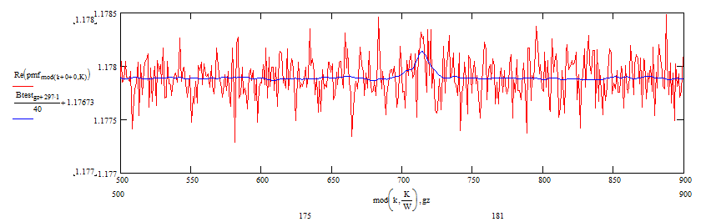

Candidate Validation
1 File Sections
The figure below shows the enhanced folded data for the first half (red) and second half (blue) of the recorded data file.
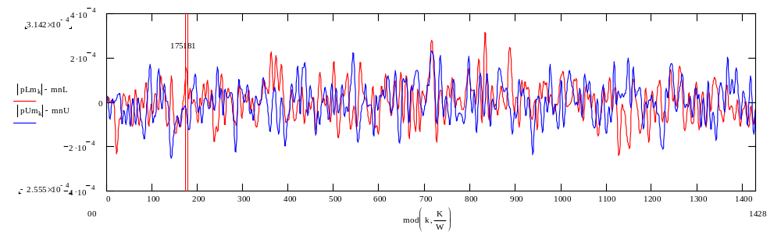
The central section shows the two sections overlapping at the file centre (bin 714) containing the pulsar candidate. To the right of centre, there are two other smaller candidates also showing overlap and half-file correlation.

2. Multi-period Correlation
In this test, the fold period is set at three times the actual period and the two half file sections overlapped in time so that positive pulse amplitude correlation around bin 714 is seen to occur in all three adjacent periods and file halves.
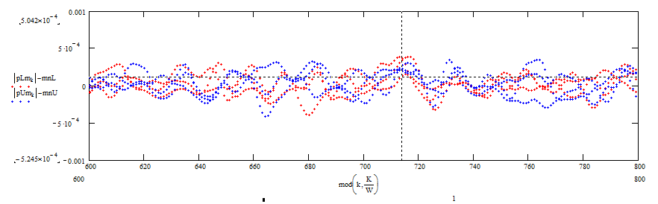

3. Band Correlation
The receiver employs three receivers of bandwidth 2.4MHz and tuned 2 MHz apart to allow for band edge rolloff. The figure below shows that the pulse coincides in the three bands (red - 609MHz, blue - 611MHz, green - 613MHz. The pulse sections only align when the correct band centre de-dispersion correction has been added.
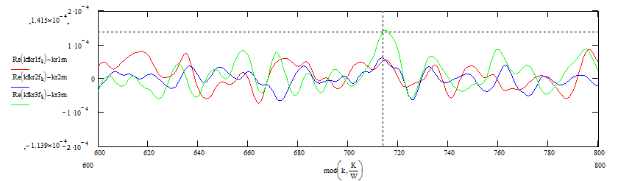


4. Pulse Width and Shape
In the following plots, a folded section of B0329 data (blue) recorded by M Klaassen using an RTL receiver with a 25m dish is overlaid compared to the present data (red),
The width (6.6ms published) and shape compare well although the slight knees on the leading edge may be coincidental.
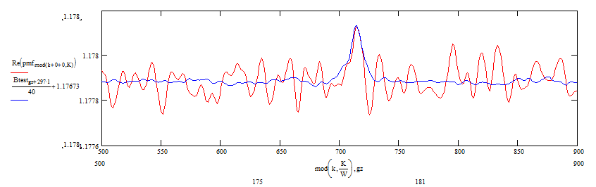

5. Scintillation
The figure below shows the indicated SNR in each band over 30min time slots of the total record.. The blue curve shows the summed version showing that less variation than the individual bands.
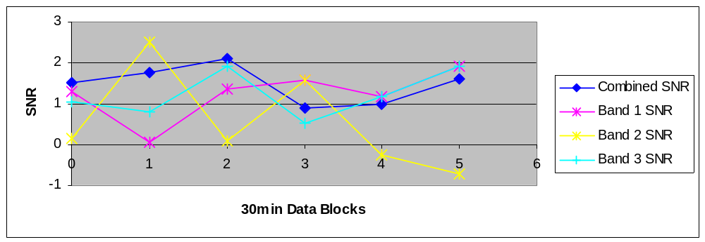

5 Tracking Small Period Changes.
The usual method of tuning the test period when folding to identify the pulsar peak changes the period in fractional parts per million to show a regular falloff either side of the matching period. With weak signals this can be made difficult as the relative position of the pulsar peak can vary with power being shared between bins and the peak moving across bins. The test can be improved by noting that the relative peak position of the pulse can be predicted and the periods adjusted to maintain the pulsar peak at the centre of wanted bins. These problems are of less importance when enhanced folding is used to improve resolution. Still, accurate pulse position movement, amplitude and width, can be predicted to confirm the pulsed nature of the wanted signal..
If T is the data record duration and P the pulsar period and t the pulse position offset at the start, then changing the period by +p ppm, the first pulse start position changes to t-pP and the last pulse to t-pT. So when folded, the average shift is -pT/2 and the pulse extent increases to pT. The plot below summarises the expected pulse width, amplitude and pulse centre position changes as a function of the period change in parts per million x data duration. The model used to derive the plots assumes a Gaussian-shaped pulse with half-height equal to the wanted pulsar pulse width. Attendant noise may, of course impose uncertainty on these predictions, but what we are looking for is consistency over a range either side of the initial set period; the half-height width of the stretched pulse can now be predicted and is a positive aid in validation.

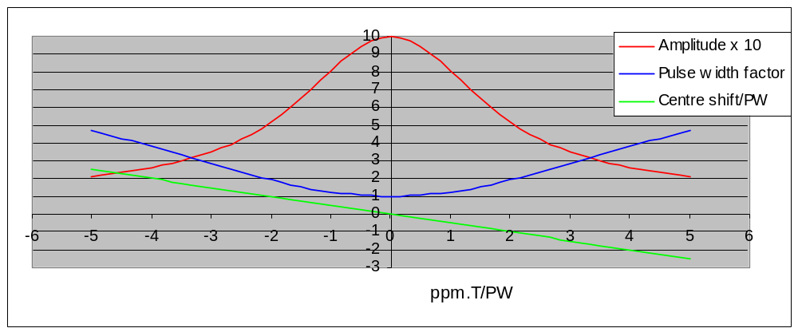

For pulsar B0329, the fold period is approximately 714ms and for the present data the record duration was 7620s, the average shift for 1ppm period change calculated is 3.8ms. With 1429bins, the bin width is 0.5ms so for 1ppm change the peak shift expected is 7.6 bins. In the first case, keeping the test B0329 reference data in a fixed (bin 714) position, the period was increased by 1ppm; the calculated shift of the pulsar pulse centre position by -7 bins is confirmed in the plot below. 3.8ms is about 0.6 x 6.6ms (pulsar pulse width) and the 90% relative amplitude change also appears consistent with the analysis. Increased validation confidence is obtained by splitting the data record into two equal parts and inspecting the relative movement in candidate positions with period change. In this instance, the first half position changes as -pT/4 and the second half by -3pT/4.

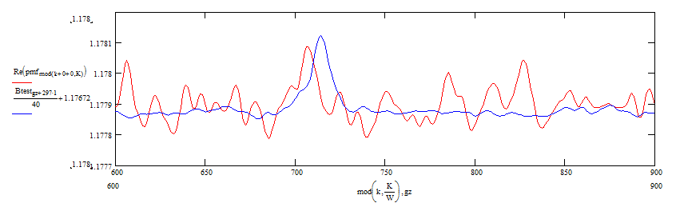
In the second case, shown below, the period was reduced by -1ppm, again moving the pulse centre by +7 bins
In both cases, the pulse amplitude dropped and the pulse appeared to broaden slightly, as expected. Further period changes confirmed the peak powers continued to drop away from the central peak.
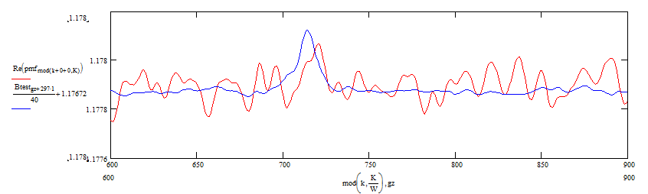

6 De-dispersion Effects.
In this section, dispersion is defined as the dispersion in ms/MHz x receiver bandwidth in MHz over and above that normally required to de-disperse the pulsar pulse.
A simple explanation of the effects of positive or negative dispersion on a pulsar pulse is that pulse increases begin to be noticed when the magnitude of the total dispersion in ms across the band approaches the pulsar pulse width. At this point, the dispersed pulse width slightly increases and the amplitude drops by 15-20%. For larger dispersion delays, the pulse width increases to equal the delay; the amplitude drops by the ratio, pulse width/delay and the dispersed pulse peak occurs at the half delay point. The expected changes based on a Gaussian pulse shape are illustrated in the following plot. This idealised situation may be observed with large SNR pulsar signals but will be obscured somewhat at low SNR’s; however, trends should still be present to aid data validation.

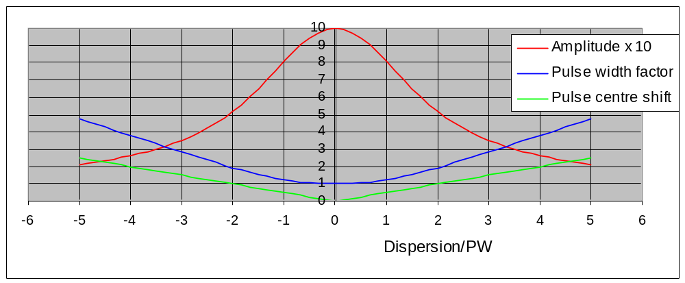

The plots in section 4 above represent the situation when the bands have been de-dispersed correctly so that all three bands pulsar peaks align.
If the de-dispersion is removed, then as shown below, the pulse appears delayed and slightly broadened. In this instance, the 3 bands have unequal integrated amplitudes, but shift in time as expected.
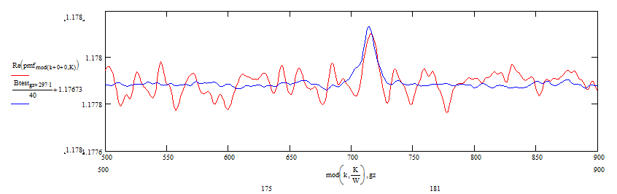

The data analysed was downsampled to 1ms samples, so that band dispersion was limited to these increments. However it was possible to show the effect of double de-dispersion as shown below. Here it is evident that the pulse more clearly reduces amplitude and is broadened due to the band component temporal shifts.
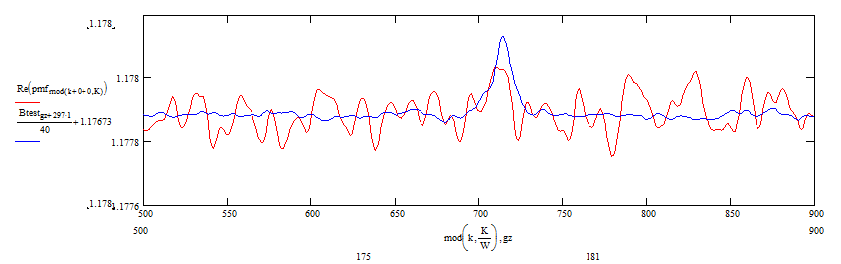
Within band de-dispersion was not necessary in this evaluation.

Conclusions
This project has been aimed at demonstrating that with a minimal receiving system comprising a pair of 17-element Yagi antennas at 611MHz and a triple RTLSDR, that it is possible to detect the B0329 pulsar albeit at a very low signal-to-noise ratio. Identifying and confirming detection at a signal-to-noise ratio close to typical Gaussian noise spikes is not easy but the enhanced folding algorithm very much helped.
Accurately specified local oscillators are essential to limit the initial search process. In the present instance, a TCXO specified to 0.5ppm was used, but could not be relied on to show the same error over many trials under different weather conditions
Novel validation measures described in this note relevant to low SNR pulsar detection and validation, include enhanced folding and specific quantitative measures associated with period tuning and dispersion analysis. The stronger tests #5 and #6 build on the pulsing nature of the wanted pulsar signal.
Because there is a high probability of ambiguity it is essential to concentrate and spend time on the validation process. Noise peaks can masquerade as pulsar-like signals and are a source of erroneous detections. All of the tests described can fall foul of noise/interference impersonations and pulsars themselves at this level do not have a 100% discriminating property. So beware - all the tests must be passed to get an A-star pulsar!

Peter W East. November 2017

